SITE-TAKEOVER/SKIN

A Site-Takeover, also known as a “Skin,” consists of banners that will run on the right- and left-hand margins of the main content area of the Modern Drummer website.

The right and left banners should include a blank area in the middle of your design, which is where the body of Modern Drummer’s website will appear. Your banners will appear outside this area. We recommend each right- and left-side banner be 400 pixels wide and between 800 to 1,200 pixels in height for the best viewing experience. The blank center area should be 1,185 pixels wide. The total image dimensions should have a width of 1,985 pixels and a height between 800 and 1,200 pixels. When users scroll down the page, your banner will be repeated on the vertical axis.

- Dimensions: 1,985 pixels wide x 800 to 1,200 pixels high
(400 pixels for the left banner + 1,185 pixels for the blank center area + 400 pixels for the right banner)
- File Format: JPG, GIF, or PNG
- Maximum Image Size: 150KB
- Please supply a URL to link to your banners.

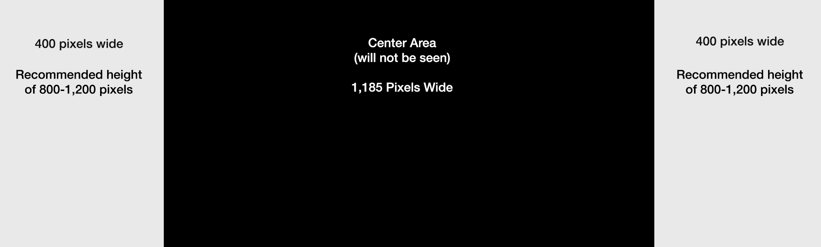

To compensate for smaller devices that do not show the take-over, we have created an “Alternate Mobile Image” that appears on devices such as mobile phones, tablets, and laptop devices. To utilize this option, at no additional charge, please supply an additional banner image with the dimensions of 1,300 pixels wide by 350 pixels high. This will ensure that your banner is visible on as many devices as possible.

- Dimensions: 1,300 width x 350 height.
- File Format: JPG, GIF, or PNG
- Maximum Image Size: 150KB
- Please supply a URL to link to your banner.

